Lancashire Enterprise Partnership Limited

Private and Confidential: NO

Tuesday, 7 November 2017

Update from the Lancashire Skills & Employment Board

Report Author: Dr M Lawty-Jones, michele.lawty-jones@lancashirelep.co.uk

Executive Summary

This report provides an update from the Lancashire Skills & Employment Board on a number of key areas of activity, and also the development of the evidence base which will feed into the refresh of the SEP and subsequent refresh of the Lancashire Skills and Employment Strategic Framework. This includes the development of a Technical Education vision for Lancashire.

Recommendation

The Lancashire Enterprise Partnership Board are asked to:
- Note the contents of the paper.
- Contribute to a discussion at the Board meeting in relation to the development of a Technical Education vision for Lancashire.

Background & Advice

1. Background
1.1 The Lancashire Skills and Employment Board continues to drive priority areas as outlined in the Lancashire Skills and Employment Strategic Framework http://www.lancashirelep.co.uk/lep-priorities/skills-employment.aspx , which was published in February 2016. This paper highlights progress against a number of key areas.
1.2 The committee are also undertaking a refresh of the evidence base, which will feed into the refresh of the Strategic Economic Plan (SEP) and in-turn a refresh of the Framework. The report highlights research currently being undertaken, including the development of a Technical Education vision for Lancashire.
2. Careers Education, Information, Advice and Guidance (CEIAG)
2.1 The Lancashire Enterprise Adviser Network, which was initiated in January 2016, is rolling out across the whole of the Lancashire area, following an initial pilot in Burnley and Blackburn with Darwen.
2.2 Essentially the Network involves funded Enterprise Coordinators (6 across Lancashire), working with a network of Enterprise Advisers (strategic business volunteers) matched to secondary schools and colleges. The Coordinators and the Advisers engage with senior leaders in the schools and colleges to support the development of careers and enterprise plans. Key is embedding planned employer encounters, to inspire young people and raise young people's insight into the local labour market, including Lancashire-based businesses. The activity aligns with the Skills and Employment Framework, which identifies CEIAG as a critical priority due to the current fragmented and inconsistent offer.
2.3 The Network is co-funded by Lancashire County Council, on behalf of the LEP, and the Careers and Enterprise Company (CEC). The Skills and Employment Board provides strategic oversight and the day-to-delivery and employment of the Enterprise Coordinators is contracted to Inspira.
2.4 At the end of September the number of schools and colleges engaged was 78 and the number of Enterprise Advisers (business volunteers) 87. By Christmas, it is anticipated that 100 schools and colleges will be engaged. The Network includes a dedicated Enterprise Coordinator in the Blackpool Opportunity Area (fully funded by CEC), working with all 13 secondary schools, academies and colleges.
2.5 Early evaluation suggests: that a step-change is underway with regard to the number of good quality employer encounters; improved teacher and tutor knowledge of current and future labour market opportunities; excellent feedback from students; improved awareness of different career pathways, including apprenticeship opportunities; and improved outcomes in Ofsted inspections.
2.6 The City Deal 'Bridge the Gap' Lego bridge building activity has been piloted in 5 secondary schools in central Lancashire throughout September. The pilot was delivered to 122 young people, 7 teachers and supported by 22 STEM Ambassadors. Over 74% of pupils said that 'Bridge the Gap' increased their interest in having a career in STEM and construction. Over 92% of pupils said they now knew more about jobs in construction. The activity is being rolled-out across all schools in the City Deal area.
3. European Structural Investment Fund (ESIF)
3.1 The performance of Lancashire's ESIF programme is considered in more detail in a report elsewhere on this agenda. As reported, the level of ESF management information provided by our Managing Authority, the Department for Work and Pensions (DWP), continues to be a concern, and was raised again at the ESIF Committee in September. A recent meeting between the national LEP Network and DWP officials raised similar issues. However, it is unclear whether this will be resolved.
3.2 It is worth noting that the Lancashire Skills Hub has established a Lancashire Skills Forum which brings together the accountable bodies of each ESF project. The purpose of the forum is to drive awareness and referrals, and ensure that activity is complementary to mainstream provision. A key focus is the implementation of the Lancashire Skills Escalator (see below) and enabling referrals from project to project to maximise sustainable employment outcomes.
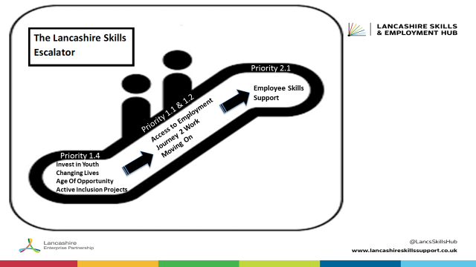

3.3 Looking ahead, there is growing concern that ESF is viewed as the primary funding source for employability programmes with many key target groups such as NEETs. Influence is required to ensure that current gaps in mainstream provision are not further exacerbated by Brexit negotiations with emerging proposals such as a new national Shared Prosperity Fund focused on both local productivity and inclusive growth priorities.
4. Growth Deal Skills Capital
4.1 The 16 projects that were approved are being monitored by the Growth Deal Programme Team. A number have completed the capital phase and outputs are now being monitored. Projects are progressing and all are currently RAG rated as green.
4.2 The opening of the Teaching Hub (University of Cumbria in Lancaster) and the launch of the Food and Farming Innovation Technology Centre (Myerscough College) both took place during September and were well attended. The opening of the Lancashire Adult Learning facility at Northlight also took place on Tuesday 17th October. The hub has been working with SKV to maximise publicity in relation to the launches and further detail will be provided in the marketing and communications update.

5. An informed Approach – Refresh of the Evidence-base
5.1 An evidence-base was established towards the end of 2015 to support the development of the Lancashire Skills and Employment Strategic Framework. This included analysis of various educational, skills and employment statistics, as well as the commissioning of 6 sector skills studies and a study into the implications of the City Deal. The existing evidence base, including Labour Market Intelligence Fact Sheets, can be accessed via the Hub's website: http://www.lancashireskillshub.co.uk/about-us/evidence-base/
5.2 The Skills & Employment Board are currently undertaking a refresh of the evidence base, which will feed into the refresh of the SEP and in-turn a refresh of the Framework.
5.3 The diagram below provides an overview. Activity includes events and skills conversations with Digital business and businesses in the Visitor Economy, a joint study with CITB analysing the supply and demand for construction skills in Lancashire and a refresh of the labour market intelligence by travel to work areas. The latter will result in a tool kit of resources, building on the positive response to the Fact Sheets from a range of education and skills providers and careers professionals. 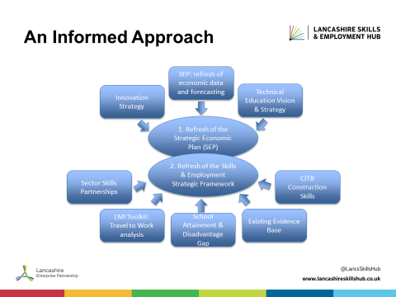

5.4 Of most significance, is the development of a new technical education vision. To this end, SDG Economic Development (SDG-ED) have been commissioned by the Skills and Employment Board to develop a clear vision for a high performing technical education system in Lancashire. The vision will encapsulate Lancashire’s future ambitions for technical education, identify objectives and priorities and suggest pragmatic recommendations for action, which are shared and owned by stakeholders.
5.5 The vision work will take into account the national policy context (including the industrial strategy, the apprenticeship reforms, the post-16 skills plan and the Northern Powerhouse developments), the forecast labour market demands in Lancashire's priority sectors, current and emerging physical learning assets and future ambitions of providers based in the Lancashire area. The vision will also feed into the LEP's emerging Innovation Plan and vice versa, recognising the correlation of skills with productivity and innovation.

5.6 Stakeholder engagement is a critical element of the vision work. The process underway is iterative and involves a number of stages involving one-to-one stakeholder consultation and workshops. Following a number of initial one-to-one stakeholder conversations, an initial workshop took place on 20 October which involved a mix of employers, providers and stakeholders. Further stakeholder interviews are planned, with view to undertaking a second workshop on 23 November to review the final draft.
5.7 SDG-ED are due to present the final draft vision at the Skills and Employment Board on 29 November. The LEP Board will be asked to consider and approve the final draft vision at its meeting in January.
6.0 Institutes of Technology
6.1 As referenced in the Industrial Strategy Green Paper, the Department for Education (DfE) are developing criteria for the proposed Institutes of Technology (IoT). The latest information suggests that IoT will be designed to raise the prestige of technical education – as a credible high quality alternative to academic routes; addressing primarily the technical skills gap at Levels 4 and 5 in STEM based industries to meet local economic needs; and enable local workforces to keep pace with rapid technological change.
6.2 DfE issued further guidance in September, asking for interested providers to register an interest, with view to the full prospectus being published before the end of 2017. This will be followed by a two stage application process which will be undertaken in 2018.

6.3 There is an expectation from DfE that LEPs will comment on bids from their local areas, with LEPs asked to rank proposals if there are multiple applications.
6.4 It is intended that the Technical Education visioning piece will help to frame the context in Lancashire, setting out ambitions and labour market requirements, building on the Area Based Review Skills Conclusion. For example, ideally an IoT in Lancashire would address the skills gaps in our STEM industries, utilise Growth Deal investments that have been made in science, engineering and digital facilities and build a collaborative approach to engaging employers and upskilling the workforce – thereby closing the gap at Level 4 and above which currently exists in Lancashire. The approach would also need to incorporate digital skills and Industry 4.0.

6.5 Interested institutions have been encouraged to connect with the LEP before the launch of the national prospectus, and collaborative discussions are currently being facilitated and encouraged.

